
Issue
Stress Awareness Month - April
Stress Awareness Month 2026 takes place throughout April with the
theme #BeTheChange, encouraging personal action and
empowerment to manage stress.
It provides an important opportunity to break the stigma around mental health, promote stress management strategies, and encourage healthier, more resilient lifestyles.
Haslingden Health Care NEWS
The Enhanced Access Service
The Enhanced Access Service in Rossendale is held at Rossendale Primary Healthcare Centre (Inside Ilex View Practice) as well as Irwell Medical Centre (Inside Irwell Medical Practice)
The service is held at Rossendale Primary Healthcare Centre, 17:00pm – 20:45pm on Tuesdays, Wednesdays, Fridays and Saturdays 9-2pm. The service is held at Irwell Medical Centre, 17:00pm – 20:45pm on Mondays and Thursdays. Appointments within this service are both Face to Face and Remote (Telephone/Video Call).
These appointments can be with either a GP, ANP, Practice Nurse or Health Care Assistant. These clinicians have access to your GP Practice record which allows them to see all results, letters and consultations to enable a continuity of care during your appointment with the Enhanced Access Service.
Web: https://eastlancashirealliance.co.uk
Facebook: https://www.facebook.com/EastLancsAlliance/
Email: Ela.servicefeedback@nhs.net

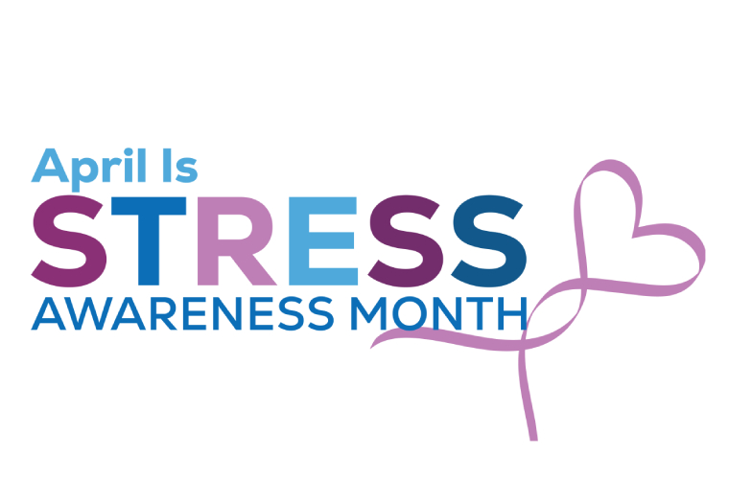
in this issue MARCH 2026 >>>

You and Your GP
For up to date information on what you can expect from us as your general practice and how you can help us so that you get the best from the NHS, please refer to our website www.haslingdenmedicalgrouppractice.co.uk
and click the document titled ‘You and your GP’

World Autism Acceptance Week
30th March – 3rd April
World Autism Acceptance Week is a dedicated period focused on raising awareness, understanding, and acceptance of autism spectrum disorder (ASD). The week aims to celebrate the uniqueness of individuals with autism, promote inclusive practices, and educate the public about the challenges and strengths of those on the autism spectrum.
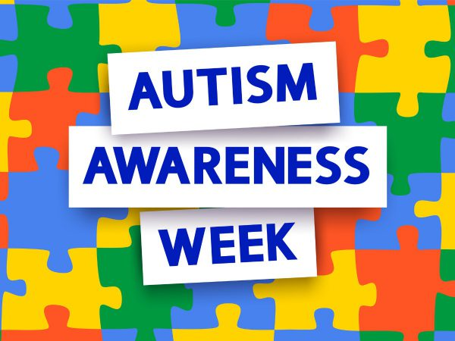
- My GP App
- Non medical queries
- Prescription Hub

- International Nurses day
- Deaf awareness week
- New staff member
- Spring covid boosters
- Clinical Trials
- Bank holiday updates
- Travel vaccines info
And MORE…
THE SPRING ISSUE


Eleanor – Mental Health Practitioner

Hello, my name is Eleanor and I am a Mental Health Nurse, I help people who are having mental health difficulties, I can offer brief interventions, including CBT influenced work and anxiety management strategies, medication advice, signposting, guided referrals to secondary care mental health services or co-working with other colleagues such as the social prescribers.

I have been a nurse for 13 years and spent most of my career working in community teams and in A&E with all ages. I have spent the last 4 years based in GP surgeries. I am currently completing training in EMDR and really hope to get my prescribing qualification someday.

I cannot see anyone who is already under MH services, or anyone where the primary need is not mental health based - for example if the primary need is neurodiverse difficulties, social issues or addiction.

In my personal life - I am married with 2 x children (2 and 6) and a dog (staffie-collie X), everyone in my family is energetic but me. We love walking and camping and I love the 1 hour each night where I can sit and do nothing
NEW STAFF!

Haslingden Healthcare are now offering a service for all patients to send directly Non-Medical Queries and Admin Requests using the link below, which includes sicknotes, letters and updates regarding test results.
You can access this service using the link below.
https://florey.accurx.com/p/P81099

You can also access this service using the NHS App.

For further information please speak to the reception team.
Patient Non Medical Queries -
International nurses day
Celebrated around the world every May 12, the anniversary of Florence Nightingale's birth.

Deaf Awareness Week 2026 theme ‘Right to understand –
Together, we break barriers.’ This week focuses on promoting inclusion, understanding, and equal access, highlighting how communication barriers, negative attitudes, and a lack of accessibility often prevent people from fully participating in society.
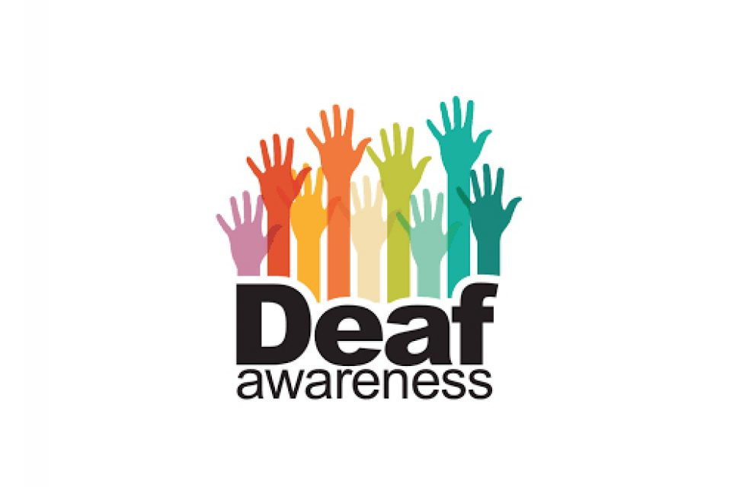

Deaf awareness week 4th- 10th May
Travel Vaccines
We are now offering NHS travel vaccines at the practice. To find out further information and to see if you are eligible, please contact reception and request a travel vaccine questionnaire form.

A questionnaire will be sent across to you to complete and return to us. A nurse will then review this form and an appointment will be made dependent on the review.

Please contact the practice at least 12 weeks in advance before your travel date to start this process
ask the experts >>>
COVID VACCINES
Spring COVID-19 booster vaccinations are now available.
If you’re eligible, you will receive a text message with details on how to book your appointment.
We will be starting our covid booster appointments week commencing 13th April.
Please keep an eye on your messages and book as soon as you can.

Home Blood Pressure Monitoring Deposits

Our practice has now implemented a new deposit scheme for loaning home blood pressure monitoring machines.

We will now require a £10 deposit before loaning you a machine - this will be returned to you when you bring the machine back to reception.

Please note if you do not bring the home monitoring machine back to reception within 2 weeks this deposit will be non-refundable.

Prebooking appointments through the MyGP App

Please note that we now have limited appointments that are available to book the night before on the MyGP App. These appointments are released at 6.30pm Sunday-Thursday.

Our new prescription hub is now live. If you are over 70 or clinically vulnerable, please contact 01706 335390 and select option 2 to order your prescription.
For anyone that does not meet the above criteria you can either email lscicb-el.macscripts@nhs.net or mackenzie.reception@nhs.net to order. Alternatively, you can order through online patient access or fill in a slip at Reception.

SMOKING CESSATION

Smoking can lead to strokes, cancer, heart and lung disease. We strongly advise quitting. The best way to stop is with a combination of medication and specialist support.

You can try the NHS Quit Smoking app, or for more information visit: www.nhs.uk/smokefree



NEW PRESCRIPTION HUB
With spring here, the days are getting warmer and the evenings lighter – a welcome change for many of us.

It also marks the start of hay fever season. If you’re affected, it’s a good idea to start your usual treatments early, such as antihistamines or nasal sprays, to help manage symptoms. If you need advice or support, please get in touch with the practice.

Spring has sprung
Clinical Trials
Stay up to date:
Facebook – Haslingden Healthcare Ltd
Website – www.haslingdenmedicalgrouppractice.co.uk
Email – mackenzie.reception@nhs.net
Number – 01706 335390

HOLIDAY CLOSURE DATES -

Friday 3rd April – Good Friday

Monday 6th April – Easter Monday

Monday 4th May – Early May Bank Holiday

Monday 25th May – Spring Bank Holiday
Holiday Closure Dates

Haslingden Healthcare is now participating in clinical trials.
Some patients may be contacted and receive a message alert about these clinical trials requesting you to join in.
If you are interested in the clinical trial then follow the instructions in the message you receive, please do not contact reception about this.
No personal or medical information will be released without your consent.

Would you like to join our PATIENT PARTICIPATION GROUP?
We are looking for enthusiastic, dedicated patients for their views on upcoming changes and to help shape the delivery of services. Some questions that could be raised are below…

- How long do I have to wait for a GP appointment?
- How can I access mental health services?
- I just want to check my blood test results, can I do this without speaking to a healthcare professional?
- Why do the receptionists need to know what my appointment is for?

For more information please contact reception:
01706 335590 or mackenzie.reception@nhs.net

Finding An Agent That’s Right For You

