

***in this issue JUNE 2025 >>>***

Issue

* *Men’s health week*
* *Staff news*
* *Breastfeeding awareness*
* *Bank holiday closure*

**Haslingden Health Care NEWS**

Led by the Men's Health Forum to raise awareness of preventable health issues and encourage men and boys to seek professional advice for health-related problems.

It also aims to give all boys and men access to the information services and treatment they need to live healthier, longer and more fulfilling lives.

***Men’s Health Week – 9th-15th June***

***World Breastfeeding Awareness Week – 1st-7th August***



WBW is celebrated every 1-7 August in commemoration of the [1990 Innocenti Declaration](https://waba.org.my/1990-innocenti-declaration-on-the-protection-promotion-and-support-of-breastfeeding/). WBW started in 1992, with annual themes including healthcare systems, women and work, the [International Code of Marketing of Breastmilk Substitutes](http://www.who.int/nutrition/publications/code_english.pdf), community support, ecology, economy, science, education and human rights.

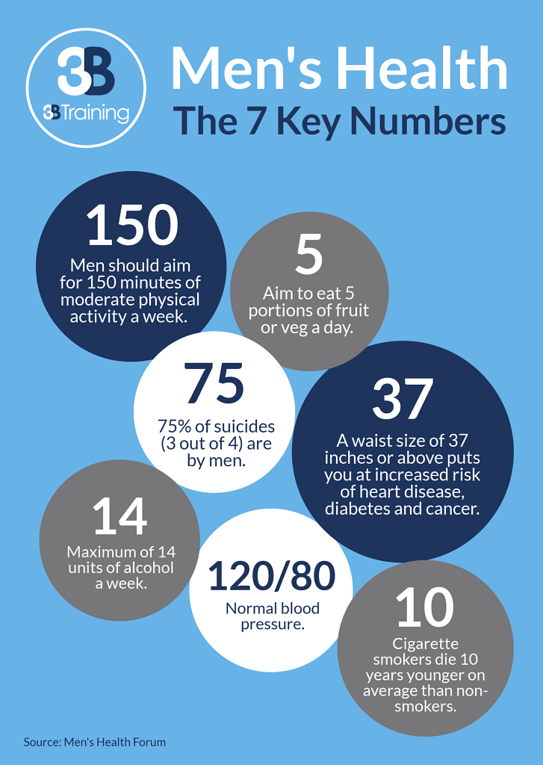

* *PPG*
* *Travel Vaccines*
* *Bike week*
* *Prebooking appointments*
* *Home blood pressure deposits*
* *Alcohol awareness week*

And MORE…

The Enhanced Access Service

The Enhanced Access Service in Rossendale is held at Rossendale Health Centre (Inside Ilex View Practice) as well as Bacup Health Centre (Inside Irwell Medical Practice)

The service is held at Rossendale Health Centre, 17:00pm – 20:45pm on Tuesdays, Wednesdays, Fridays and Saturdays 9-2pm. The service is held at Bacup Health Centre, 17:00pm – 20:45pm on Mondays and Thursdays. Appointments within this service are both Face to Face and Remote (Telephone/Video Call).

These appointments can be with either a GP, ANP, Practice Nurse or Health Care Assistant. These clinicians have access to your GP Practice record, to enable them to see all results, letters and consultations to enable a continuity of care during your appointment with the Enhanced Access Service.

Web: [**https://eastlancashirealliance.co.uk**](https://eastlancashirealliance.co.uk/)

Facebook: [**https://www.facebook.com/EastLancsAlliance/**](https://www.facebook.com/EastLancsAlliance/)

Email: [**Ela.servicefeedback@nhs.net**](mailto:Ela.servicefeedback@nhs.net)

**THE SUMMER ISSUE**



**Dr Choudry**

Hi my name is Ayesha and I am one of the new Foundation Year 2 Doctors who will be at the practice until August. I am passionate about providing holistic, patient-centred care, and I am particularly interested in Dermatology and Women's Health. I look forward to supporting the Haslingden community with their health needs, and will always be happy to address your concerns however big or small!

**Laith Alwan**

Hi I’m Laith a physician associate with over four years’ experience. I see acute and chronic disease patients under the clinical supervision of a senior GP. I have a qualifications in, Bsc Biomedical Sciences and MSc Physician Associate Studies

*Staff News!*



Bike Week - 9th-15th June

Encouraging people to get out cycling and switch to cycling as the best way to get around. 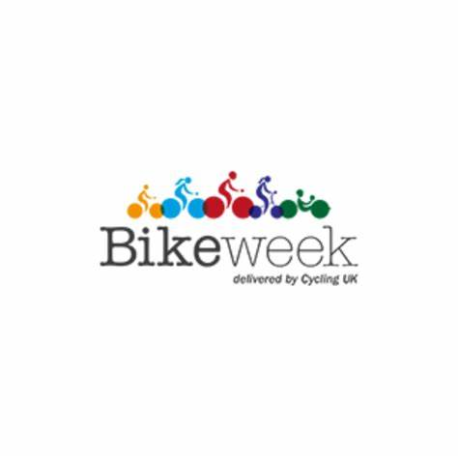

A chance for the UK to get thinking about drinking. It’s a week of awareness-raising, campaigning for change, and more. This year the theme is alcohol and work. Discussing the relationship between alcohol and work to help us better understand it and sharing some helpful tips and advice on changes we can make to improve things for us all.

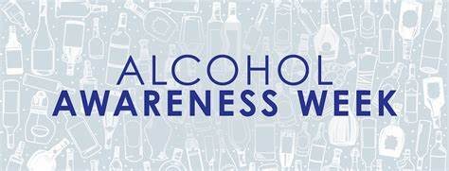

Travel Vaccines

We are now offering NHS travel vaccines at the practice. To find out further information and to see if you are eligible, please contact reception and request a travel vaccine questionnaire form.

A questionnaire will be sent across to you to complete and return to us. A nurse will then review this form and an appointment will be made dependent on the review.

**Please contact the practice at least 12 weeks in advance before your travel date to start this process**

Haslingden Healthcare are now offering a service for all patients to send directly Non-Medical Queries and Admin Requests using the link below, which includes sicknotes, letters and updates regarding test results.

You can access this service using the link below.

[**https://florey.accurx.com/p/P81099**](https://florey.accurx.com/p/P81099)

**You can also access this service using the NHS App.**

**For further information please speak to the reception team.**

Alcohol Awareness Week – 7th-13th July

*Patient Non Medical Queries -*

***ask the experts >>>***

**Prebooking appointments through the MyGP App**

Please note that we now have limited appointments that are available to book the night before on the MyGP App. These appointments are released at 6.30pm Sunday-Thursday.

SMOKING CESSATION

Smoking can lead to strokes, cancer, heart and lung disease. We strongly advise quitting. The best way to stop is with a combination of medication and specialist support.

*You can try the NHS Quit Smoking app, or for more information visit:* [*www.nhs.uk/smokefree*](http://www.nhs.uk/smokefree)



**The practice will be closed on the following date:**

**Monday 25th August – Summer bank holiday**

**For urgent requests please contact NHS 111. In an emergency dial 999.**

**Home Blood Pressure Monitoring Deposits**

Our practice has now implemented a new deposit scheme for loaning home blood pressure monitoring machines.

We will now require a £10 deposit before loaning you a machine - this will be returned to you when you bring the machine back to reception.

*Please note if you do not bring the home monitoring machine back to reception within 2 weeks this deposit will be non-refundable.*

SHINGLES VACCINES

We are offering shingles vaccines to those who are eligible.

Please note that you will receive a text message if you are eligible asking you to book in.

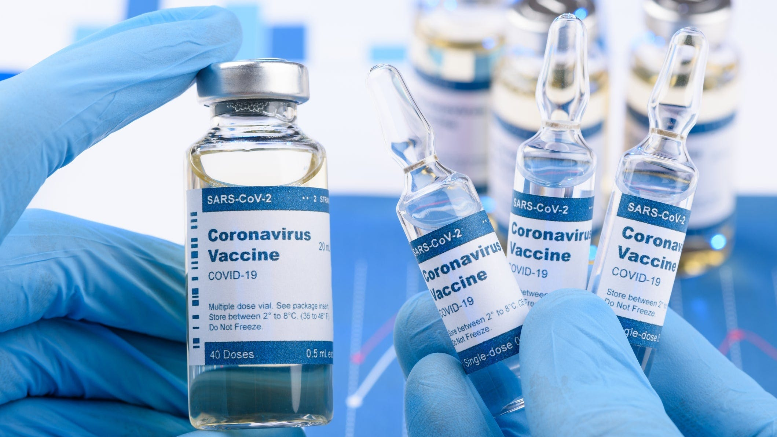

*Bank Holiday Closures…*



**It is officially Summer!** Light nights and hotter days are upon us.

Please make sure to keep your skin protected when the sun is at its hottest by wearing SPF.

***The warmer days are here…***

Haslingden Healthcare is now participating in clinical trials.

Some patients may be contacted and receive a message alert about these clinical trials requesting you to join in.

If you are interested in the clinical trial then follow the instructions in the message you receive, please do not contact reception about this.

**No personal or medical information will be released without your consent.**



Clinical Trials

Prescriptions

Just a gentle reminder to patients that our prescription phone line is open from 9.00am-12.00pm.

Alternatively, you can order prescriptions through the NHS app or email

Lscicb-el.macscripts@nhs.net

**Stay up to date:**

Facebook – Haslingden Healthcare Ltd

Email – [mackenzie.reception@nhs.net](mailto:mackenzie.reception@nhs.net)

Number – 01706 335390

Would you like to join our PATIENT PARTICIPATION GROUP?

We are looking for enthusiastic, dedicated patients for their views on upcoming changes and to help shape the delivery of services. Some questions that could be raised are below…

* How long do I have to wait for a GP appointment?
* How can I access mental health services?
* I just want to check my blood test results, can I do this without speaking to a healthcare professional?
* Why do the receptionists need to know what my appointment is for?

For more information please contact reception:

01706 335590 or mackenzie.reception@nhs.net

*Finding An Agent That’s Right For You*